Power BI learning Useful Resources
Fast Track approach
The Power BI learning methodology involves understanding the 4 pillars of development
- Connecting to data sources, data transformation and loading (ETL)
- Data Modeling
- DAX programming
- Data Visualization and Report Design
Step 1:
Go to app.enterprisedna.co and create a free account.
Complete these 2 free courses covering the 4 pillars (around 6 hours duration). Do the ultimate beginners guide to Power BI first.
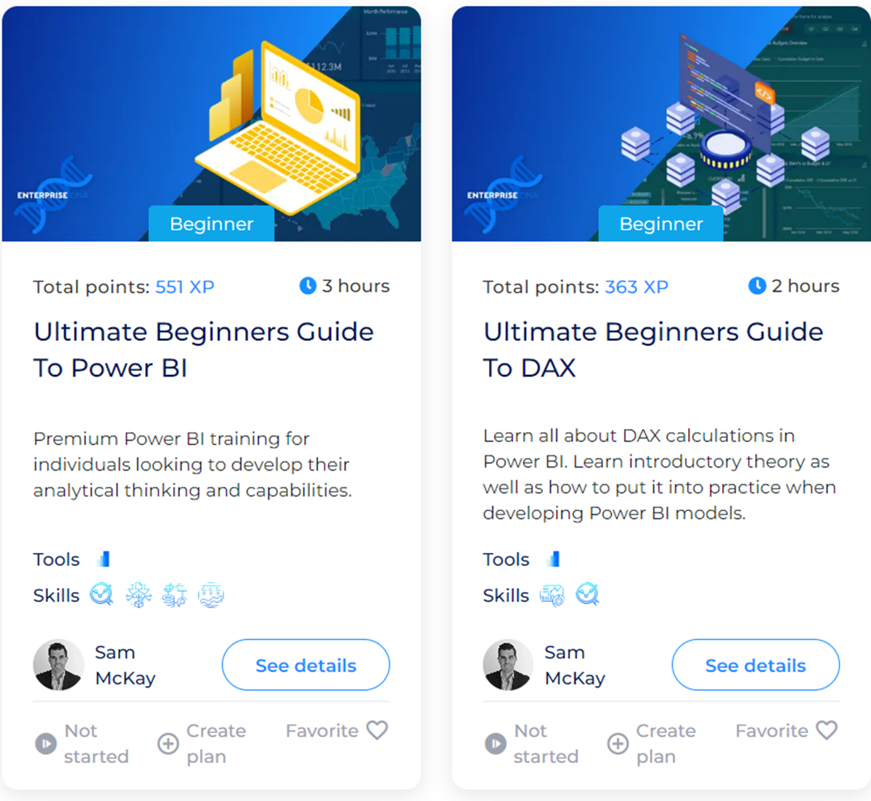
You can also watch these YouTube tutorials to improve your learning. These videos are more detailed than the ones above
End to End: https://www.youtube.com/watch?v=77jIzgvCIYY
Data Modeling: https://www.youtube.com/watch?v=MrLnibFTtbA
DAX Programming: https://www.youtube.com/watch?v=QJw4HkagVWc
Report design and Data Storytelling: https://www.youtube.com/watch?v=SvVucB-oISo
Step 2: Develop at least 4 to 5 end to end guided projects
Project 1: Sales Insights
https://www.youtube.com/watch?v=hhZ62IlTxYs&list=PLeo1K3hjS3uva8pk1FI3iK9kCOKQdz1I9
Project 2: Data Professionals Survey
https://www.youtube.com/watch?v=pixlHHe_lNQ&list=PLUaB-1hjhk8HqnmK0gQhfmIdCbxwoAoys&index=9
Project 3: Hospitality domain
https://www.youtube.com/watch?v=tT4V7zguCnc&list=PLeo1K3hjS3uv_e0HUEu1CVCOikPay64p8
Project 4: HR Analytics
https://www.youtube.com/watch?v=ru1qeDO_qrc&list=PLeo1K3hjS3uuVQccZa7yFwK3ltoGQOWbM
Project 5: Personal Budget and Finance management
https://www.youtube.com/watch?v=ru1qeDO_qrc&list=PLeo1K3hjS3uuVQccZa7yFwK3ltoGQOWbM
Step 3: Participation in data challenges
Every month there is a new challenge where a dataset is given to challenge participants and they need to create a report. Some of these challenges are open for all kinds of BI tools like Power BI, Tableau, Looker, Qlik etc. Some are just Power BI specific. This is perhaps the best way of learning any BI tool and you get to win prizes as well as LinkedIn visibility.
Maven analytics: https://mavenanalytics.io/challenges
FP20 Analytics: https://www.fp20analytics.com/challenges
Onyx Data: https://onyxdata.co.uk/data-dna-dataset-challenge/
Step 4: Creating a data portfolio on GitHub or Novypro (You need to publish Power BI reports and need a Pro / trial account for it). You can also create your own webpage.
Here are some examples
https://github.com/tiannaparris/Data-Analysis-Portfolio
https://github.com/PriyankaJhaTheAnalyst/DataAnalystPortfolioProjects
https://www.novypro.com/profile_projects/abu-bakar-nisar-alvi669674
https://www.novypro.com/projects?Popup=memberProfile&Data=1682149256278x750817161245696400
https://francisfolaranmi.wixsite.com/theanalystpharmacist

Long terms learning resources:
Requirements Gathering for any project
https://www.youtube.com/watch?v=Au_blsKBNMk
https://www.youtube.com/watch?v=S4VpHzBW2N8
https://data-goblins.com/power-bi/report-requirements
https://www.youtube.com/watch?v=Jx6uvvT2QMI
Data Transformation and Loading (Power Query)
https://youtu.be/VO-MyVMKUC4
https://gorilla.bi/power-bi/best-learning-resources/
Using Python / R in Power BI
https://youtu.be/F2M4F4sUDw8
https://youtu.be/u2qQExgN7Mc
https://youtu.be/8_ZtQgwszv4
Data Modeling
https://youtu.be/vr304H4O2tQ
https://youtu.be/WjXZWA279Cw
https://youtu.be/LtesFDU-77I
https://youtu.be/j6aICyU0xqk
https://youtu.be/lXk0ZiKpRYI
https://youtu.be/qVK1e-H8CiA
https://www.youtube.com/watch?v=Ce0FGXHmHcw
https://www.youtube.com/watch?v=5oPHIZ_4Src
Data Modeling books
https://www.amazon.com/Expert-Data-Modeling-Power-reporting/dp/1803246243
https://www.amazon.com/Data-Warehouse-Toolkit-Definitive-Dimensional/dp/1118530802
DAX Programming
https://youtu.be/yzcYvs_18NQ
https://www.youtube.com/watch?v=DwuAypulTLA&list=PLDz00l_jz6zwdC_xdTp_QANkHYIzs1BJG
https://www.youtube.com/watch?v=pabn7kLxN6c&list=PLDz00l_jz6zym_YP8ZW11o52niGfCP8pN
sqlbi.com
dax.guide
DAX Books
The Definitive Guide to DAX: https://www.amazon.com/Definitive-Guide-DAX-intelligence-Microsoft/dp/1509306978
Supercharge Power BI:
https://www.amazon.com/Supercharge-Power-BI-Better-Learn/dp/1615470522
Power BI Report Development and Visualization
https://visualisingdata.com/resources/
https://miro.com/app/board/uXjVMn3WomE=/?moveToWidget=3458764563299736588&cot=14
https://primaconsulting.co.uk/news/blog-power-bi-reports-it-is-ok-to-keep-it-simple
https://www.moonstory.design/blog/categories/ux-design
https://www.valeriejunk.nl/en/
https://datavizfairy.co.uk/b2vb-tips/
https://www.youtube.com/watch?v=Z_4PdsfUmwE
https://www.youtube.com/watch?v=M0S3dAG2xdE
https://www.youtube.com/watch?v=2M3OKx00yYc
https://nastengraph.substack.com/p/dataviz-101-key-principles-for-crafting

YouTube Channels for learning Power BI
Some YouTube channels and portfolio links for report design inspiration
Gustaw Dudek portfolio: https://www.novypro.com/profile_projects/gustaw-dudek
Alexandru Badiu portfolio: https://www.novypro.com/profile_projects/alex-badiu524803
Gerrard Druggan portfolio: https://www.novypro.com/profile_projects/gerard-duggan
Mathhew Spuffard: https://baseone.uk/demo/
Sean Chandler: https://mavenanalytics.io/profile/Sean-Chandler/157152432
Kerry Kolosko: https://kerrykolosko.com/
Isabelle Bittar: https://medium.com/@isabittar
Greg Philips: https://www.novypro.com/profile_projects/greg-philps856432
Rachwen Mosbehi: https://www.novypro.com/profile_projects/rachwen-mosbehi227173
Armand van Amersfoort: https://www.youtube.com/channel/UCGfGpfdEsGwiJG3d9D02r8Q
Power BI Park: https://www.youtube.com/channel/UC6g1VsTNgW1ntdW97wwL6nw
Thais Cooke: https://thaiscooke.github.io/
Yan Holtz: https://www.yan-holtz.com/

Dashboard design inspiration
- novypro.com
- https://dribbble.com/search/uxdesign
- https://www.behance.net/galleries/ui-ux
Some inspirational dashboard designs
https://app.powerbi.com/view?r=eyJrIjoiYTFjMGY4ZGUtYjQ0My00YmZiLWE3NWQtNjc1MWM1MDliYmQ5IiwidCI6ImM2ZTU0OWIzLTVmNDUtNDAzMi1hYWU5LWQ0MjQ0ZGM1YjJjNCJ9&pageName=ReportSection2e4fa8708c540abcd366
https://app.powerbi.com/view?r=eyJrIjoiYjkzYTg3YmQtYWRmNy00ZTQ5LTg4YmYtYzhlMWRmMTFkNmI0IiwidCI6Ijk3MzljOGZhLWQ0MGUtNDYyYy1hYWFkLWEzMGJkZDVmNGUzZCIsImMiOjl9
https://app.powerbi.com/view?r=eyJrIjoiOTMyYWI1MjItMmQyNS00YjFiLWJiMzktMTcyZmEzNDQ5ODYwIiwidCI6Ijk3MzljOGZhLWQ0MGUtNDYyYy1hYWFkLWEzMGJkZDVmNGUzZCIsImMiOjl9
LinkedIn Profile Optimization
https://www.youtube.com/watch?v=j2YA_TScR-E&pp=ygUdbGlua2VkaW4gcHJvZmlsZSBvcHRpbWl6YXRpb24%3D
https://www.youtube.com/watch?v=A5yLk6JnTV0&pp=ygUdbGlua2VkaW4gcHJvZmlsZSBvcHRpbWl6YXRpb24%3D
https://www.youtube.com/watch?v=DGhCxRVe-Vw&pp=ygUdbGlua2VkaW4gcHJvZmlsZSBvcHRpbWl6YXRpb24%3D

